211 Bedford Park Boulevard  Apartment.5F  Bronx,NewYork,10458 | Tel : 347 284 - 3258  Mobile: 347 981 - 2687  e-mail: aytuldeveli@hotmail.com
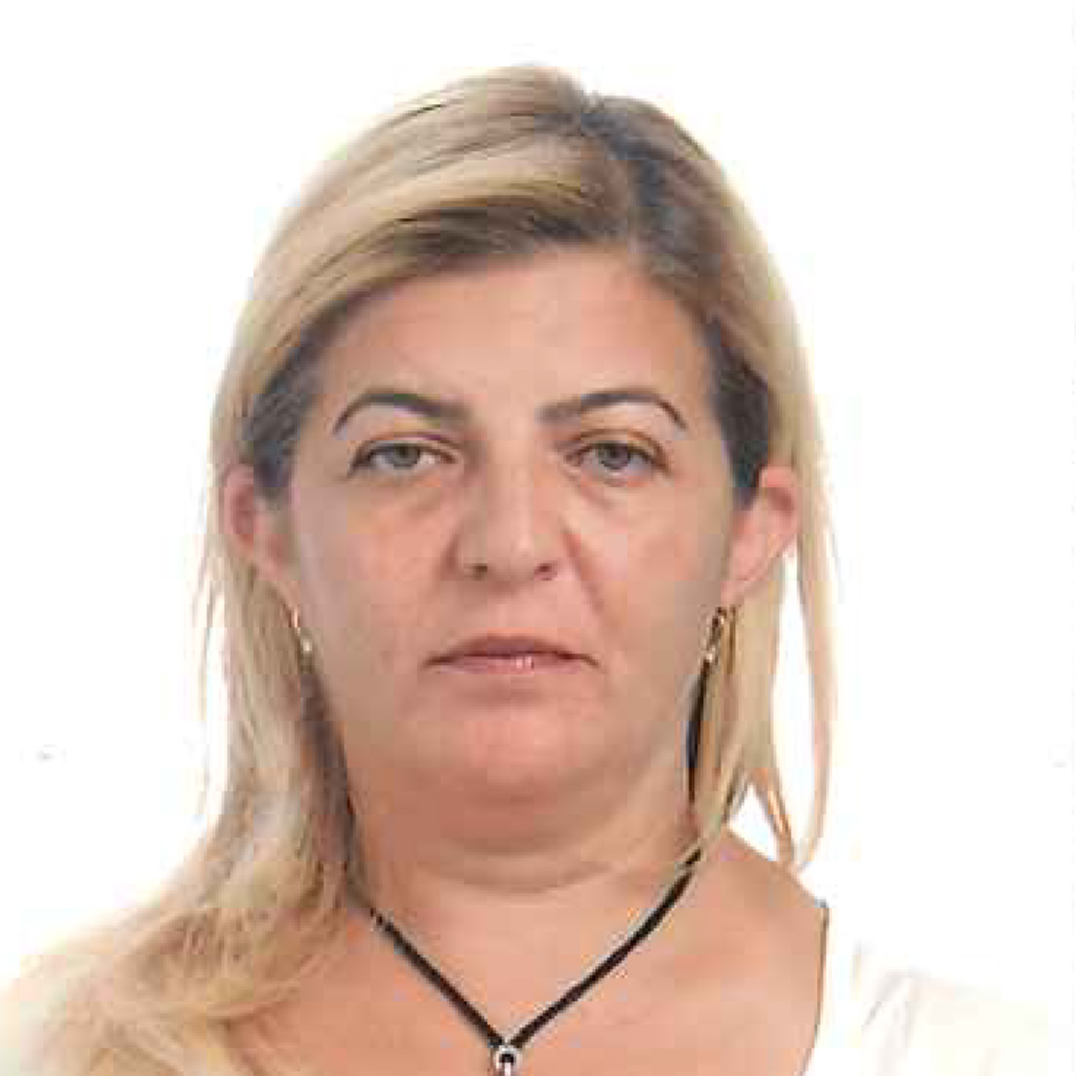
Aytül Ergul Develi
Personal Information | Place and Date of Birth: Manisa / 29.04.1963
Experience | - 2009-2012  PAKISTAN EMBASSY INTERNATIONAL STUDY GROUP  A level – O Level English Literature  IGCSE ESL-English Literature Teacher  - 1990–2005 (retired)  HACETTEPE UNIVERSITY  SCHOOL OF FOREIGN LANGUAGES Ankara  - 1998-2005  Department of Post-Preparatory English Courses  - taught Reading I, Reading II, Writing, Oral  Communication Skills, Academic Research Skills  and Translation courses.  - Academic Research Skills Course and Testing Coordinator  in 2000-2001 academic year.  - Reading I / II Course and Testing Coordinator in 1999-2000  academic year.  - 1990–1998  Department of Preparatory English Courses  - taught engineering and philology students Elementary,  Intermediate, Upper-Intermediate and Advanced English.  - taught ESP courses; such as, English for Biology students,  English for Mining Engineering students, English for Sports  Science and Technology students.  - gave TOEFL courses to Turkish research assistants assigned  to obtain their M.A. and Ph.D. degrees in the U.K. or the U.S.A.  - 1983-1989  Türkiye İş. Bankası A.Ş.  - worked as an expert in Foreign Exchange Department
Education | • 1998-to the present Hacettepe University Ankara  - Ph.D. student at English Literature Department  • 1991-1996 Hacettepe University Ankara  - M.A. degree in English Literature  Thesis on: Concept of Nature in Seamus Heaney’s Poetry  • 1980-1984 Hacettepe University Ankara  - B.A. degree in English Language and Literature Department  • 1977-1980 TED ANKARA COLLEGE Ankara  • 1974-1977 American International School Kabul/Afghanistan
Publications | • 1998  - compiled course book: Academic Research Skills  • 1997  - compiled and prepared ESP course book: English for Biology  Students  - compiled and prepared ESP course book: English for Mining  Engineering Students I  - compiled and prepared ESP course book: English for Mining  Engineering Students II  - compiled and prepared ESP course book: English for Sports  Science and Technology Students  • 1992  - compiled reading course book with two other colleagues:  Learning to Read

